Note: please kindly note that you should use the correct firmware and you should operate the updating in correct way, or radio will be in chaos like following photo

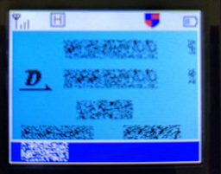

1. Press PTT and alarm key( on the top) to turn on the radio, the indicator blinks and open upgraded software

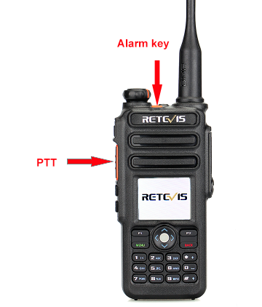 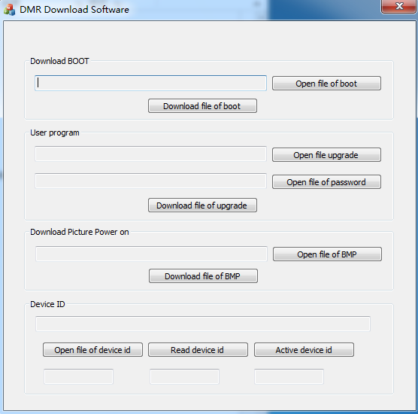

1. And then click Open file upgrade, choose the firmware you need.

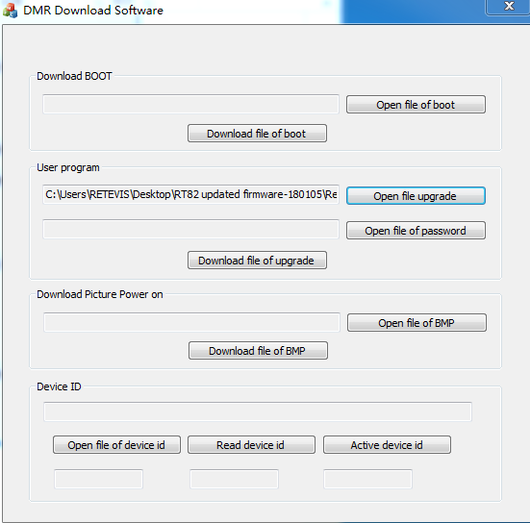

1. Click Download file of upgrade ,write upgraded file into radio, the radio will be upgraded as following:

